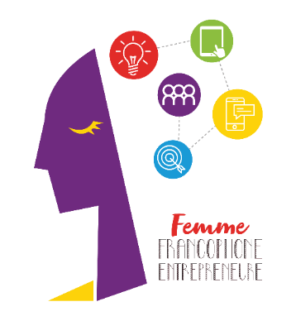

Press Release

20,000 Euros shared among 3 francophone entrepreneur women

Beirut, October 3, 2022 – Despite the critical economic situation that Lebanon is enduring, women who take risks, try to make a name for themselves, and embark with ambition on an entrepreneurship journey are more than ever present. Is there a more powerful sign to revive the hope for a Lebanon which is not only a place of crises but a country of initiative and dynamism? After 10 years at the service of women’s entrepreneurship, AUF and its partners decided to breathe new life into the Femme Francophone Entrepreneure competition, by rewarding this year two start-ups and an SME. The verdict was rendered on Friday during the final which took place at the Centre d’Employabilité Francophone of AUF in Beirut: Rafa Hojeij, Nora Berbery and Israa Hoss won the final competition.
This contest, which is organized by AUF Middle East and Berytech, in partnership with L'Orient-Le Jour, has been promoting, for more than a decade, women’s entrepreneurship in Lebanon. Partners still believe in the potential of startups despite the difficulties which are inherent to the Lebanese ecosystem; this year, they decided to support SMEs whose great merit is to have braved the strains of a crisis that is growing increasingly smothering.
The call for participation was issued in April 2022. One hundred projects were received; 33 participants were selected and followed several training sessions. The submitted projects were assessed in light of criteria such as innovation, market study, viability, and complementarity between the team members’ competencies in order to select the projects that will make it to the final.
Six participants competed during the final:
- Rafa Hojeij - Potion Kitchen – a « Clean » beauty brand made in Lebanon by using a variety of Mediterranean renewable ingredients extracted from freshly cut plants without adding toxic chemical products;
- Rania Kassir - Happy Brain – a publishing house for speech therapy materials and tools targeting the Arabic speaking population and executed with the help of scientific experts from the sector and the field;
- Israa Hoss - Vini Fera – a selection of upcycled local grapes, which are worthwhile for the skin care market and which extend the life cycle of Mediterranean grapes;
- Nora Berbery - TwiLy – a French-Lebanese business that decided to revolutionize the world of training by innovating through gamification. With its educational tools or game boards, TWiLY makes training more accessible and pleasant for students and professionals alike;
- Rouba Haddad - The Bone Guy – a Lebanese startup specializing in the production of 100% natural and nutritional dog and cat treats;
- Sarah Joseph - Olive Bio – a business that offers traditional and natural agricultural products.
Each participant had 5 minutes to make their « pitch » in front of the jury and try to convince them of the relevance and viability of their projects.
Following this presentation, the three winners were chosen by the jury which included this year Michelle Mouracade (Impact Fund adviser at Al Fanar NGO), Randa Safah (non-banking subsidiaries and private investment officer at Banque Audi), and Philippe Hage Boutros (economic journalist at L’Orient-le Jour).

Rafa Hojeij, Nora Berbery and Israa Hoss will share 20,000 Euros and will be allocated an area within Berytech co-working space in addition to access to training and coaching for six months.

Jean-Noël Baléo, the regional director of AUF Middle East, declared in his opening speech: “Francophone entrepreneur women are showing us brilliantly today the combination of solutions and talents that the country is badly in need of, namely creativity, expertise, energy, determination, and faith in a future that is shaped here in Lebanon”.

The general director of Berytech, Maroun Chammas, asserted: “The participants in the Femme Francophone Entrepreneure competition are pumping a necessary dose of hope into our dire reality. The success of their projects bears testimony to their entrepreneurial spirit which places emphasis on the role of women in our region and preserves, at the same time, the Francophonie, which is a key element of our culture. It is quite incredible to see such enthusiasm during this period”.

Fouad Khoury Helou, the executive director of L’Orient-Le Jour, said “Lebanese women play a crucial role in rebuilding our country. Entrepreneurship, which is the foundation of our economy, will be a necessary pillar in that regard”.

Media Contact:
Joëlle Riachi
Communication officer
AUF Middle East
joelle.riachi@auf.org
Phone: +961 3 780928

