
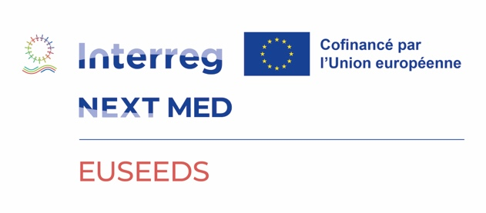

Press Release
-------------------------------------------------------------------------------------------------------------------------

Official launch of the EUSEEDS project:
strengthening youth employability in the Mediterranean

Beirut, September 10, 2025 – The Middle East regional directorate of the Agence Universitaire de la Francophonie (AUF) officially launched on September 3, 2025, the EUSEEDS project (Enable, Upgrade and Spread Employability, Entrepreneurship and Digital Skills of the Eastern Mediterranean youth through dedicated university centers), co-financed by the European Union under the Interreg NEXT MED program.
Led by AUF in Lebanon as the project coordinator, this ambitious initiative aims to strengthen the employability, entrepreneurial mindset, and digital skills of young people in the Eastern Mediterranean by supporting the creation and consolidation of dedicated university centers.
The total budget of the EUSEEDS project amounts to €2,808,499.10, of which €2,499,564.20 (89%) is funded by the European Union under the Interreg NEXT MED program.
The kick-off meeting, organized online by AUF, brought together all project partners: Center for Social Innovation (CSICY, Cyprus), Enroot (Egypt), Aix-Marseille University (France), Jordan Youth Innovation Forum (JYIF, Jordan), Forward MENA (Lebanon), and Palestine Information and Communications Technology Incubator (PICTI, Palestine).
This launch event created an immediate dynamic of collaboration and cohesion among the partners, presented the objectives, expected results, and activities of the project, addressed financial and communication aspects, and initiated the operational calendar for the first semester.
In his opening remarks, Jean-Noël Baléo, AUF Middle East regional director, emphasized the ambition and social dimension of this project, which seeks to generate significant outcomes with short-, medium- and long-term impacts, notably through the establishment of sustainable university structures.
The first concrete step of the project will be the launch of a call for applications to select 20 beneficiary universities across five partner countries (Cyprus, Egypt, Jordan, Lebanon, and Palestine). These institutions will be supported in developing or strengthening their employability centers, which serve as vital bridges between academic training and the professional integration of young people.
Through EUSEEDS, AUF and its partners, with the support of the European Union, reaffirm their shared commitment to a Mediterranean youth better prepared for the challenges of the labor market and able to contribute actively to the economic and social development of the region.

Useful links:
www.auf.org
www.interregnextmed.eu

Press Contact AUF Middle East Joëlle Riachi joelle.riachi@auf.org +961 3 780 928

